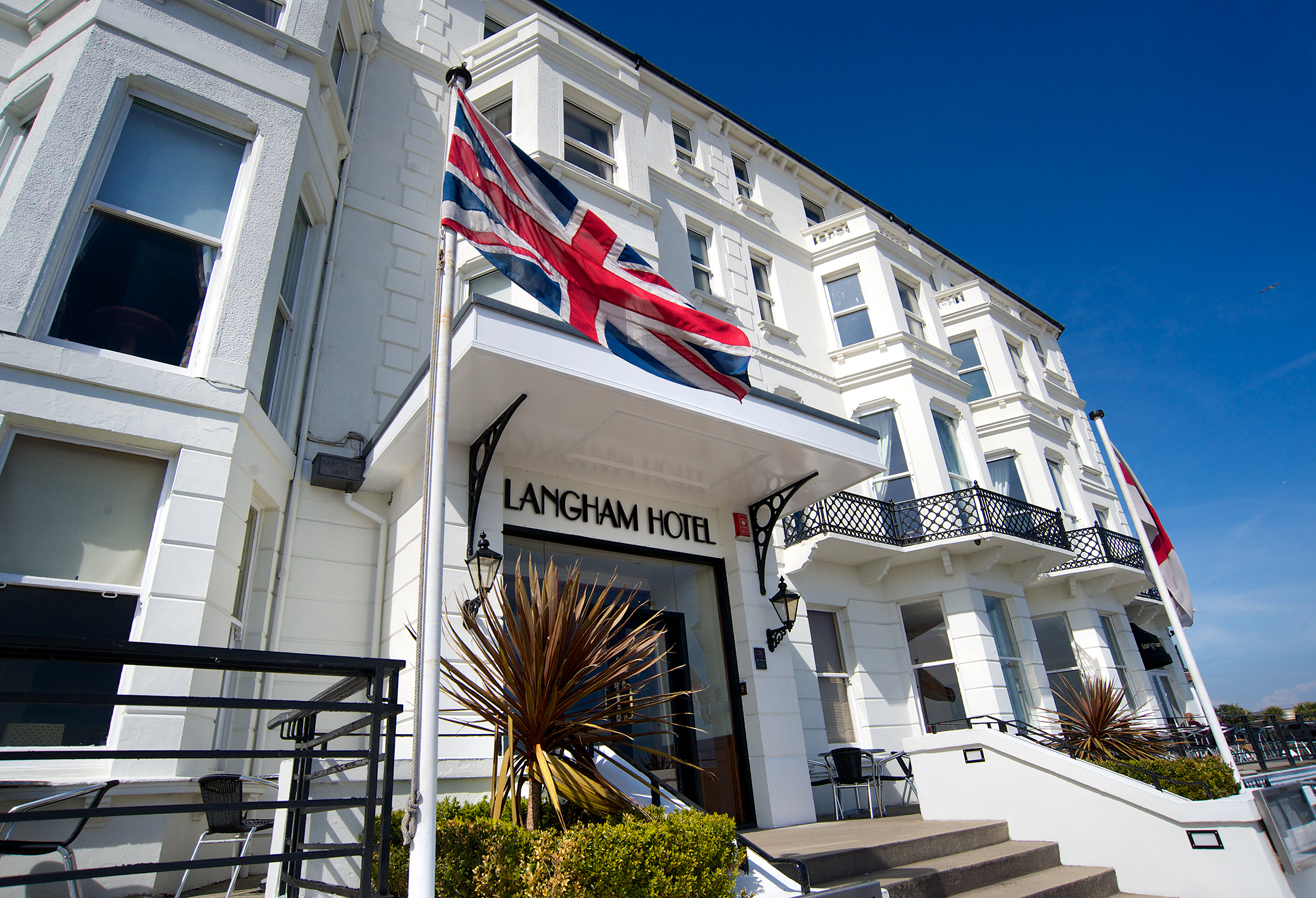

Menus
For Every Occasion
2021

The Langham Hotel
43-49 Royal Parade, Eastbourne, BN22 7AH.
Tel: 01323 731451 e-mail: frontdesk@langhamhotel.co.uk
www.langhamhotel.co.uk

We are delighted that you are considering the Langham Hotel
as a venue for your forthcoming event.

Our menus are all priced at £32.00 per person and include
place cards, a table plan and a personalised menu card.

Please select one of our menus for your guests to enjoy.
A pre-order from everybody will also be required.

We are happy to cater for any special dietary requirement.
Please do let us know in advance of any allergens.

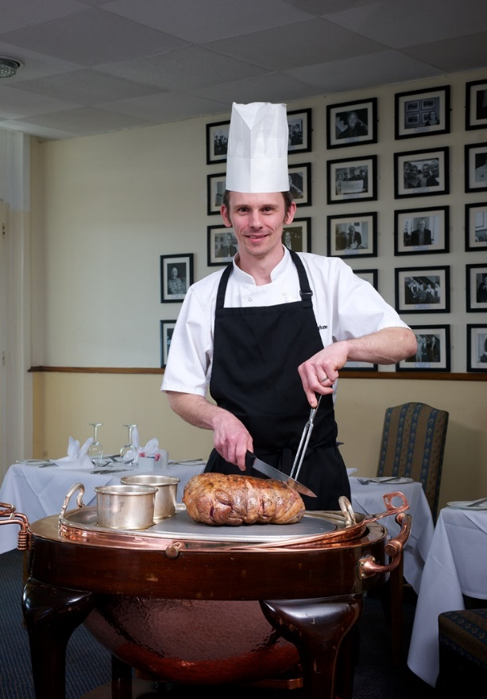

Our Executive Chef, Michael Titherington and the Langham Team
are always glad to chat through any ideas and personal requirements.

Menu A

Tomato and basil soup with gruyere scone

Smoked haddock and cheddar cheese fish cake, poached egg and mornay sauce

Goats cheese mousse, roasted beetroots, hazelnut and rocket salad toasted ciabatta

Melon cocktail, prosecco, strawberry and mint syrup

~~0~~

Supreme of chicken, sage and mushroom mousse baked in a pastry trellis

Slow cooked belly of pork braised red cabbage, spiced pear puree

Roast cod fillet, mussel and dill broth

All dishes come with a selection of seasonal vegetables and potatoes

Asparagus and minted pea risotto, parmesan biscuit (V)

~~0~~

French apple tart, cinnamon syrup, sauce anglaise and vanilla ice cream

Bitter chocolate torte, raspberry sorbet, raspberry tuille

Millionaires’ sundae
Shortbread and fudge, caramel and triple chocolate chip ice creams,
caramel drizzle, flaked chocolate and fudge pieces

Selection of cheese and biscuits with grapes and celery

~~0~~

Royal Colombian blend filter coffee and chocolate mints
Selection of tea and infusions available

Allergen data is held on each of our dish ingredients.
Please ask should you require any more information.

Menu B

Seasonal vegetable minestrone soup with garden herbs

Salad of heritage tomatoes, mozzarella, avocado and balsamic

Crayfish cocktail, watercress, pickled cucumber and a tomato mayonnaise

Pressed ham hock, grain mustard and sage pots, spiced apple and pear salad

~~0~~

Slow cooked confit of beef, mixed mushroom and ale sauce

Slow cooked chicken leg with almond, thyme and leek stuffing,
pancetta infused sauce

Baked salmon fillet, sage and lemon crust, asparagus cream

Individual mushroom and nut wellington with vegetable gravy (V)

All dishes come with a selection of seasonal vegetables and potatoes

~~0~~

Apple and blackberry pudding, caramelised crumble, vanilla ice cream
and English custard

Meringue with strawberries, Grand Marnier cream and orange syrup

Millionaires’ sundae
Shortbread and fudge, caramel and triple chocolate chip ice creams,
caramel drizzle, flaked chocolate and fudge pieces

Selection of cheese and biscuits with grapes and celery

~~0~~

Royal Colombian blend filter coffee and chocolate mints
Selection of tea and infusions available

Allergen data is held on each of our dish ingredients.
Please ask should you require any more information.

Menu C

Butternut squash soup with coriander croutons

Blue cheese croquettes, pear and walnut salad, port dressing

Seared mackerel, roasted beets and pickled fennel

Asparagus and Parma ham, crispy egg, bearnaise sauce

~~0~~

Breast of chicken, crispy skin, sweetcorn and oyster mushrooms, leek cream

Seared South Downs lamb rump, garlic and rosemary

Fillet of plaice with grapes, spring onions and Chablis butter sauce

All dishes come with a selection of seasonal vegetables and potatoes

Cauliflower and chickpea biryani, coriander rice, baby poppadoms (V)

~~0~~

Chocolate fondant, coffee parfait, ginger snap

Lemon tart, cracked raspberry meringue, ripple ice cream

Millionaires’ sundae
Shortbread and fudge, caramel and triple chocolate chip ice creams,
caramel drizzle, flaked chocolate and fudge pieces

Selection of cheese and biscuits with grapes and celery

~~0~~

Royal Colombian blend filter coffee and chocolate mints
Selection of tea and infusions available

Allergen data is held on each of our dish ingredients.
Please ask should you require any more information.

